**DEPARTMENT OF CS**

|  |  |  |
| --- | --- | --- |
| **Course No: CS F342**  **Date: Week #07**  **Id No:** | **TUTORIAL 7** | **Course Title: Computer Architecture**  **Name:** |

1. Given x = 0101 and y = 1010 in twos complement notation (i.e., x = 5, y = -6), compute the product with Booth’s algorithm.

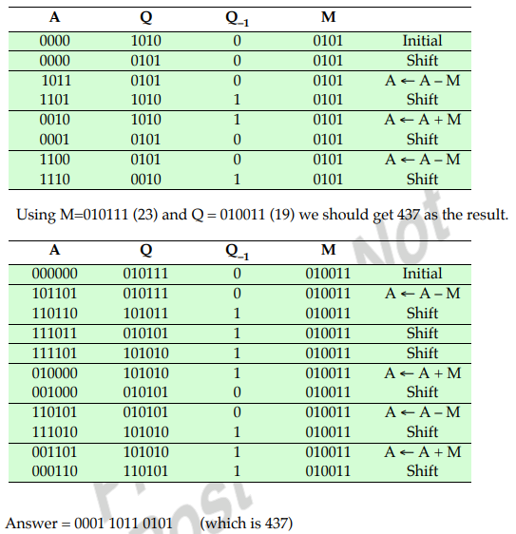

2. Use the Booth algorithm to multiply 23 (multiplicand) by 19 (multiplier), where each number is represented using 6 bits.

